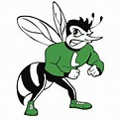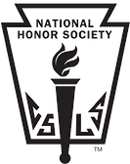
Name ____________________________ Date(s) of Activity _______ Location___________________
Time toward NHS Requirements _______ (To use these hours with other clubs, please photocopy before turning in).
Time Spent on this Activity_____________
Please select the category that this activity applies to:
____ Public Library Work ____ Church Outreach
____ School Related (Lincoln) ____ School Related (Other)
____ Senior Citizen Help ____ Ecological Help (Environmental)
____ Special Events ____ Non-profit Organization / Misc.
____ Sports Related ____ NHS Club Service
____ Homeless/Abused/Needy People ____ Medical Work
Please write a brief description of what was accomplished:

Verify Signature___________________________________________
Name of Person Verifying____________________________________
Position ________________________ Phone number _____________
Please Remember: Hours must be completed for a non-profit organization and must be in some way contributing to a group, a large number of people, or a society as a whole. Regular church activities are not considered community service, however church activities benefiting the community as a whole are acceptable. Any work you do that would otherwise be paid for is not permitted. You are encouraged to volunteer at athletic events that benefit non-profit organizations only. If you have any questions or are not sure on the validity of your service hours, ask an officer or Ms. Farokhi.
All Service Hours must be Pre-Approved with President or Adviser’s Signature.

